EXPERIMENTS

NAME:BHARANI DHARAN S
REG NO:192424141
COURSE CODE:DSA0602 DATA HANDLING AND VISUALIZATION

SET 1 – PRODUCT INVENTORY MANAGEMENTDATASET
Product ID | Product Name | Quantity Available
1 | Product A | 250
2 | Product B | 175
3 | Product C | 300
4 | Product D | 200
5 | Product E | 220

QUESTION 1

Create a bar chart to visualize the quantity of each product in the inventory. Label the axes and title the chart.

AIM

To create a bar chart to visualize the quantity available for each product.

PROCEDURE
· Create the product inventory data.
· Store product names and quantities.
· Use the barplot() function.
· Label the X-axis and Y-axis.
· Give a suitable title to the chart.
· Display the bar chart.

CODE

product_name <- c("Product A", "Product B", "Product C", "Product D", "Product E")
quantity <- c(250, 175, 300, 200, 220)

barplot(
quantity,
names.arg = product_name,
xlab = "Product Name",
ylab = "Quantity Available",
main = "Product Inventory Quantity",
ylim = c(0, 350)
)
OUTPUT

RESULT
Thus, the bar chart was successfully created to visualize the quantity available for each product.

QUESTION 2

Generate a stacked bar chart to show the quantity of each product within different product categories.

AIM
To create a stacked bar chart showing product quantities according to different product categories.

PROCEDURE
- Create product names, categories, and quantities.
- Create a data frame.
- Arrange the data according to categories.
- Use the xtabs() function to create category-wise data.
- Use the barplot() function to create the stacked bar chart.
- Add labels and a legend.

CODE
product_name <- c("Product A", "Product B", "Product C", "Product D", "Product E")
category <- c("Electronics", "Electronics", "Grocery", "Grocery", "Stationery")
quantity <- c(250, 175, 300, 200, 220)

inventory <- data.frame(
Product_Name = product_name,
Category = category,
Quantity = quantity
)

stacked_data <- xtabs(
Quantity ~ Category + Product_Name,
data = inventory
)

barplot(
stacked_data,
beside = FALSE,
xlab = "Product Category",
ylab = "Quantity Available",
main = "Stacked Bar Chart of Product Inventory",
legend.text = TRUE,
ylim = c(0, 500)
)
OUTPUT

RESULT
Thus, the stacked bar chart was successfully created to represent product quantities within different categories.

QUESTION 3

Build a scatter plot to explore the relationship between product price and quantity available. Explain the findings.

AIM
To create a scatter plot to study the relationship between product price and quantity available.

PROCEDURE
- Create product names.
- Enter product prices and available quantities.
- Create a data frame.
- Use the plot() function.
- Plot price on the X-axis and quantity on the Y-axis.
- Add product names to the points.
- Observe the relationship.

CODE
product_name <- c("Product A", "Product B", "Product C", "Product D", "Product E")
price <- c(500, 750, 300, 450, 250)
quantity <- c(250, 175, 300, 200, 220)

inventory <- data.frame(
Product_Name = product_name,
Price = price,
Quantity = quantity
)

plot(
inventory$Price,
inventory$Quantity,
xlab = "Product Price",
ylab = "Quantity Available",
main = "Product Price vs Quantity Available",
pch = 19
)

text(
inventory$Price,
inventory$Quantity,
labels = inventory$Product_Name,
pos = 3
)
OUTPUT

RESULT
Thus, the scatter plot was successfully created to analyze the relationship between product price and quantity available.

QUESTION 4

Develop a Tableau dashboard with the bar chart and stacked bar chart to allow users to interact with the data.

AIM
To develop an interactive Tableau dashboard using the product inventory data.

PROCEDURE
- Open Tableau.
- Enter the product inventory data.
- Create a worksheet for the bar chart.
- Drag Product Name to Columns.
- Drag Quantity Available to Rows.
- Create another worksheet for the stacked bar chart.
- Drag Category to Columns.
- Drag Quantity Available to Rows.
- Drag Product Name to Color.
- Create a new dashboard.
- Add both charts to the dashboard.
- Add filters for Product Name and Category.
- Enable interaction between the charts.

CODE
library(shiny)
library(ggplot2)

inventory <- data.frame(
Product_ID = c(1, 2, 3, 4, 5),
Product_Name = c("Product A", "Product B", "Product C", "Product D", "Product E"),
Category = c("Electronics", "Electronics", "Grocery", "Grocery", "Stationery"),
Quantity_Available = c(250, 175, 300, 200, 220)
)

ui <- fluidPage(
titlePanel("Product Inventory Dashboard"),

sidebarLayout(
sidebarPanel(
selectInput(
"category",
"Select Category:",
choices = c("All", unique(inventory$Category))
)
),

mainPanel(
plotOutput("barChart"),
plotOutput("stackedChart")
)
)
)

server <- function(input, output) {

filtered_data <- reactive({
if (input$category == "All") {
inventory
} else {
inventory[inventory$Category == input$category, ]
}
})

output$barChart <- renderPlot({
ggplot(filtered_data(), aes(x = Product_Name, y = Quantity_Available)) +
geom_bar(stat = "identity") +
labs(
title = "Product Inventory Quantity",
x = "Product Name",
y = "Quantity Available"
)
})

output$stackedChart <- renderPlot({
ggplot(filtered_data(), aes(x = Category, y = Quantity_Available, fill = Product_Name)) +
geom_bar(stat = "identity") +
labs(
title = "Stacked Bar Chart of Product Inventory",
x = "Product Category",
y = "Quantity Available"
)
})
}

shinyApp(ui = ui, server = server)

OUTPUT
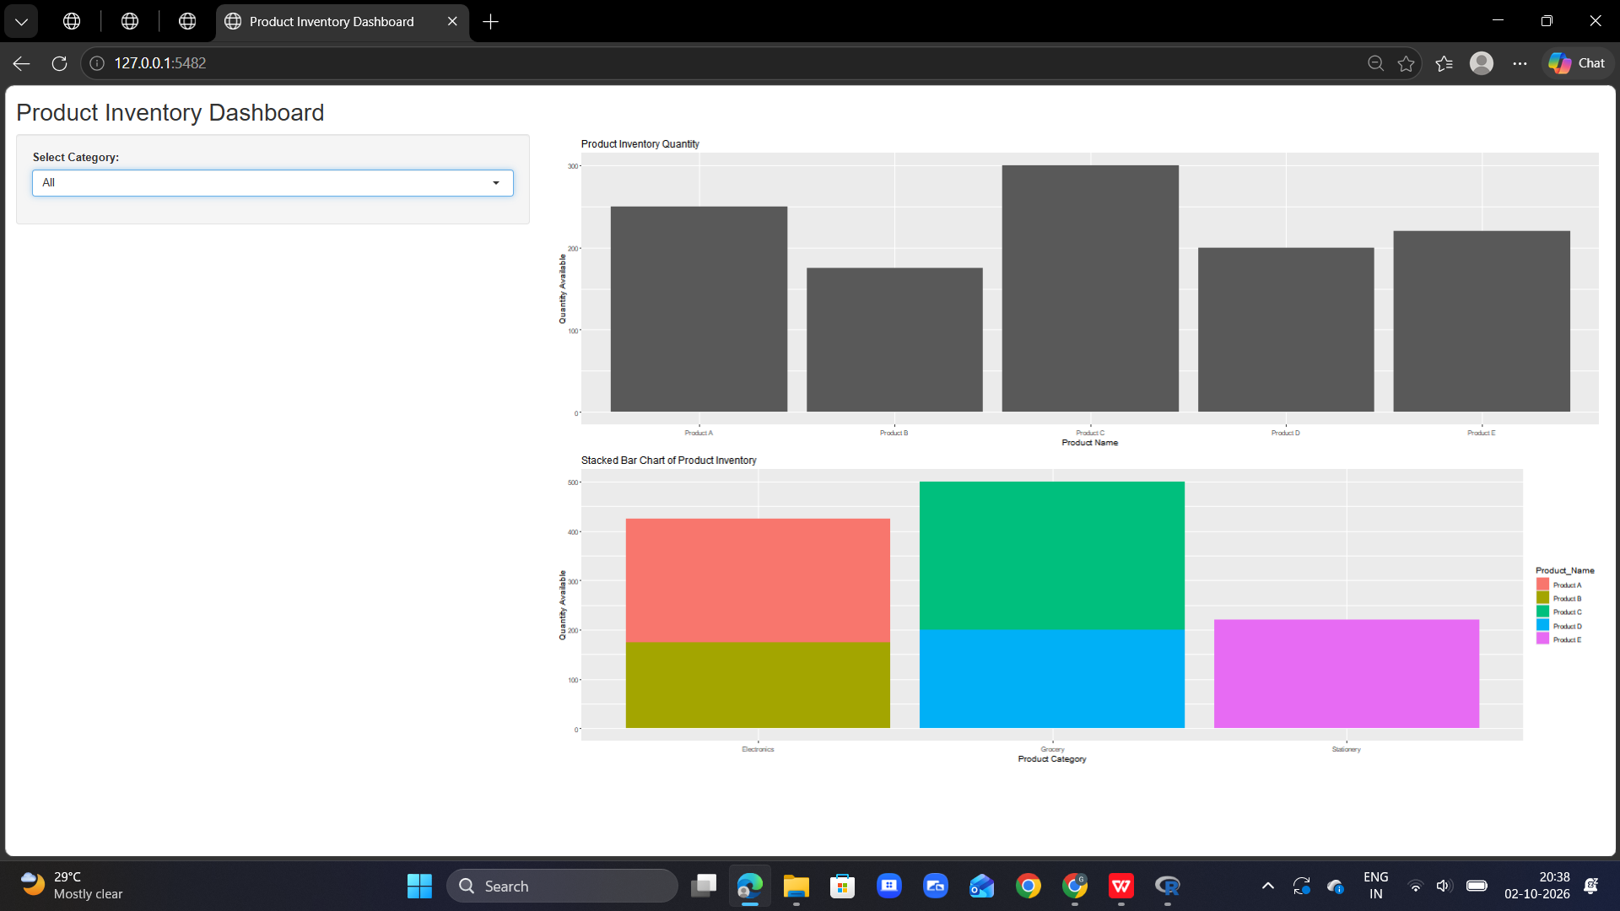

RESULT
Thus, an interactive product inventory dashboard was successfully developed in R using Shiny, containing a bar chart and a stacked bar chart.

